Check to see if each ERD is in 1NF. If not, make the necessary changes to correct it.
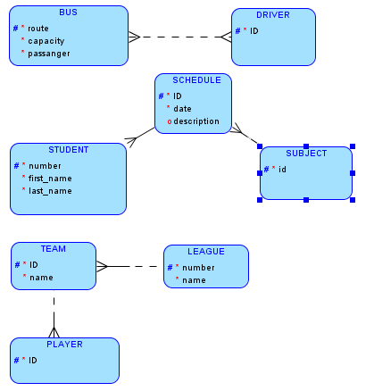

2. The UID of a library book includes its BOOK number and SHELF number. Does this ERD follow the rules of Second Normal Form? If you spot a violation, correct it.
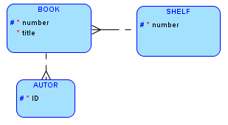

3. Cass Enrollment is the intersection entity that resolves the M:M between STUDENT and CLASS. Does the ERD follow the rules of Second Normal Form? If you spot a violation, correct it.

YES

4. Identify the transitive dependency in the model below. State which attributes violate Third Normal Form.
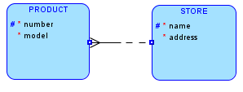

5. A color scheme for a car includes specifications for paint color for the body and the interior colors and materials. For example: The “Desert” color scheme includes silver paint and gray leather interior; the “Sunburst” color scheme includes gold paint and cream leather interior. Does the model below follow the rules of Third Normal Form? If you spot a violation, correct it.
